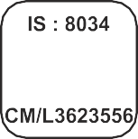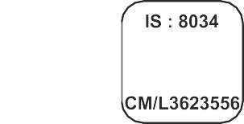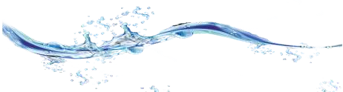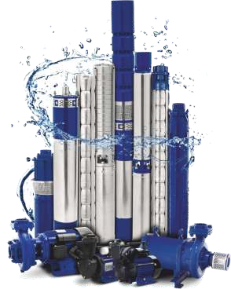

®

***SUBMERSIBLE & MONOBLOCK PUMPS***



®

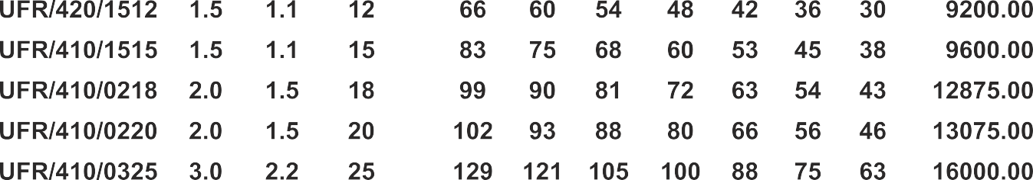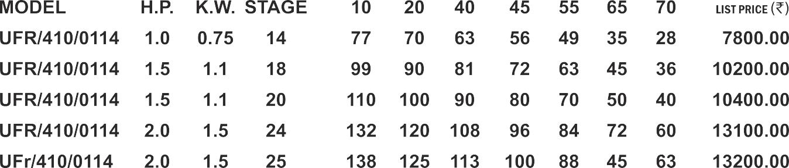



|  |  |  |  |
| --- | --- | --- | --- |
|  |  |  |  |
|  |  |  |  |
|  |  |  |  |

|  |  |  |  |  |  |  |  |  |
| --- | --- | --- | --- | --- | --- | --- | --- | --- |
|  |  |  |  |  |  |  |  |  |
|  |  |  |  |  |  |  |  |  |
|  |  |  |  |  |  |  |  |  |

V4

|  |  |  |  |
| --- | --- | --- | --- |
|  |  |  |  |
|  |  |  |  |
|  |  |  |  |
|  |  |  |  |
|  |  |  |  |
|  |  |  |  |

|  |  |  |  |  |  |  |  |
| --- | --- | --- | --- | --- | --- | --- | --- |
|  |  |  |  |  |  |  |  |
|  |  |  |  |  |  |  |  |
|  |  |  |  |  |  |  |  |
|  |  |  |  |  |  |  |  |
|  |  |  |  |  |  |  |  |
|  |  |  |  |  |  |  |  |



|  |  |  |  |
| --- | --- | --- | --- |
|  |  |  |  |
|  |  |  |  |
|  |  |  |  |
|  |  |  |  |
|  |  |  |  |
|  |  |  |  |
|  |  |  |  |

|  |  |  |  |  |  |  |  |
| --- | --- | --- | --- | --- | --- | --- | --- |
|  |  |  |  |  |  |  |  |
|  |  |  |  |  |  |  |  |
|  |  |  |  |  |  |  |  |
|  |  |  |  |  |  |  |  |
|  |  |  |  |  |  |  |  |
|  |  |  |  |  |  |  |  |
|  |  |  |  |  |  |  |  |

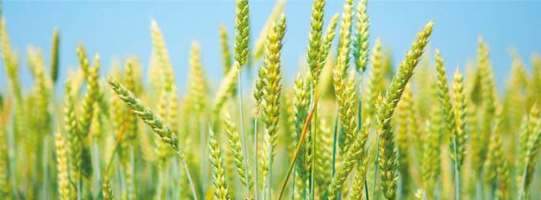

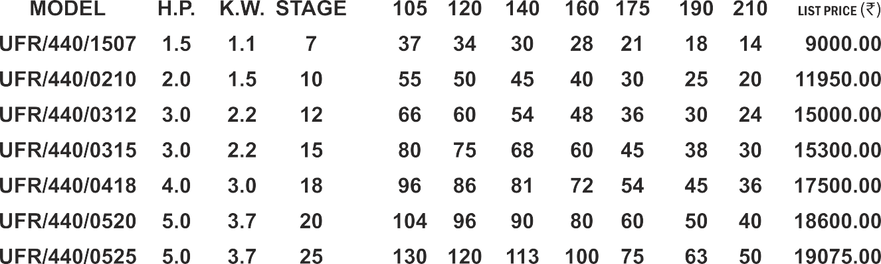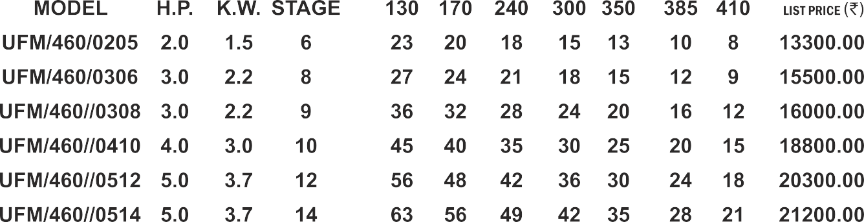

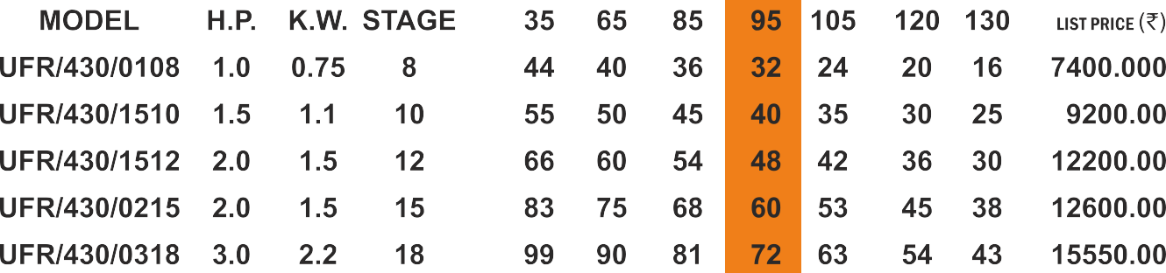



|  |  |  |  |
| --- | --- | --- | --- |
|  |  |  |  |
|  |  |  |  |
|  |  |  |  |
|  |  |  |  |
|  |  |  |  |
|  |  |  |  |

|  |  |  |  |  |  |  |  |
| --- | --- | --- | --- | --- | --- | --- | --- |
|  |  |  |  |  |  |  |  |
|  |  |  |  |  |  |  |  |
|  |  |  |  |  |  |  |  |
|  |  |  |  |  |  |  |  |
|  |  |  |  |  |  |  |  |
|  |  |  |  |  |  |  |  |

|  |  |  |  |
| --- | --- | --- | --- |
|  |  |  |  |
|  |  |  |  |
|  |  |  |  |
|  |  |  |  |
|  |  |  |  |
|  |  |  |  |
|  |  |  |  |
|  |  |  |  |

|  |  |  |  |  |  |  |  |
| --- | --- | --- | --- | --- | --- | --- | --- |
|  |  |  |  |  |  |  |  |
|  |  |  |  |  |  |  |  |
|  |  |  |  |  |  |  |  |
|  |  |  |  |  |  |  |  |
|  |  |  |  |  |  |  |  |
|  |  |  |  |  |  |  |  |
|  |  |  |  |  |  |  |  |
|  |  |  |  |  |  |  |  |

|  |  |  |  |
| --- | --- | --- | --- |
|  |  |  |  |
|  |  |  |  |
|  |  |  |  |
|  |  |  |  |
|  |  |  |  |
|  |  |  |  |
|  |  |  |  |

|  |  |  |  |  |  |  |  |
| --- | --- | --- | --- | --- | --- | --- | --- |
|  |  |  |  |  |  |  |  |
|  |  |  |  |  |  |  |  |
|  |  |  |  |  |  |  |  |
|  |  |  |  |  |  |  |  |
|  |  |  |  |  |  |  |  |
|  |  |  |  |  |  |  |  |
|  |  |  |  |  |  |  |  |

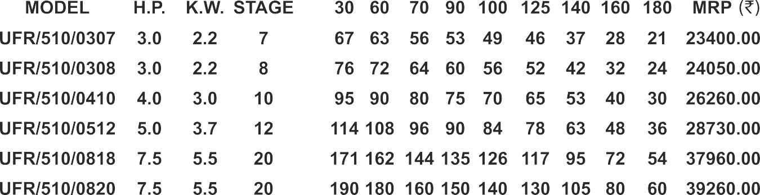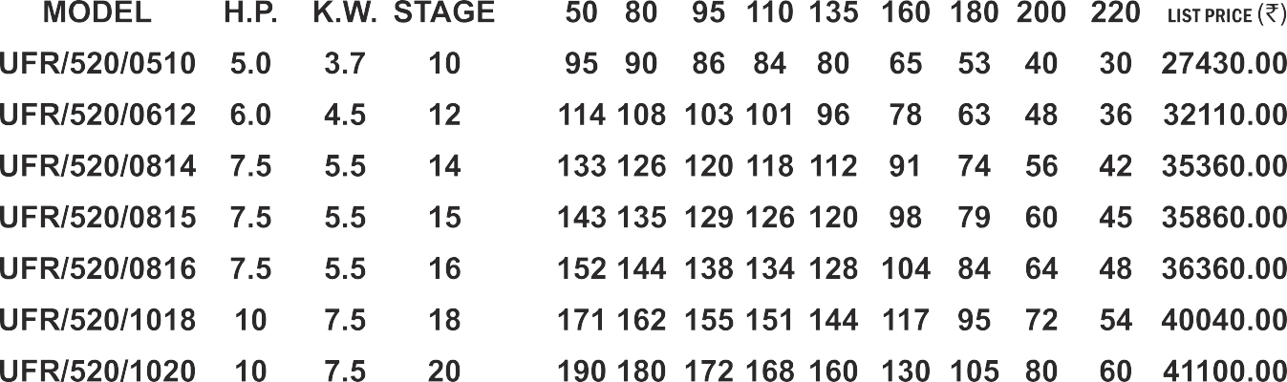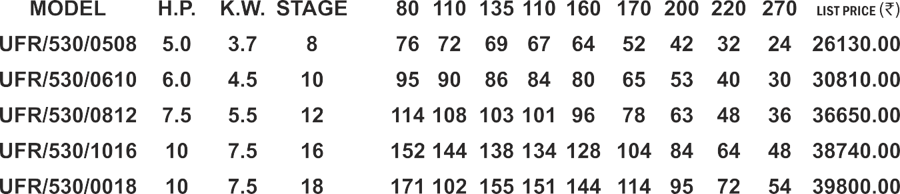

|  |  |  |  |
| --- | --- | --- | --- |
|  |  |  |  |
|  |  |  |  |
|  |  |  |  |
|  |  |  |  |
|  |  |  |  |
|  |  |  |  |
|  |  |  |  |

|  |  |  |  |  |  |  |  |  |  |
| --- | --- | --- | --- | --- | --- | --- | --- | --- | --- |
|  |  |  |  |  |  |  |  |  |  |
|  |  |  |  |  |  |  |  |  |  |
|  |  |  |  |  |  |  |  |  |  |
|  |  |  |  |  |  |  |  |  |  |
|  |  |  |  |  |  |  |  |  |  |
|  |  |  |  |  |  |  |  |  |  |
|  |  |  |  |  |  |  |  |  |  |

|  |  |  |  |
| --- | --- | --- | --- |
|  |  |  |  |
|  |  |  |  |
|  |  |  |  |
|  |  |  |  |
|  |  |  |  |
|  |  |  |  |
|  |  |  |  |
|  |  |  |  |

|  |  |  |  |  |  |  |  |  |  |
| --- | --- | --- | --- | --- | --- | --- | --- | --- | --- |
|  |  |  |  |  |  |  |  |  |  |
|  |  |  |  |  |  |  |  |  |  |
|  |  |  |  |  |  |  |  |  |  |
|  |  |  |  |  |  |  |  |  |  |
|  |  |  |  |  |  |  |  |  |  |
|  |  |  |  |  |  |  |  |  |  |
|  |  |  |  |  |  |  |  |  |  |
|  |  |  |  |  |  |  |  |  |  |

|  |  |  |  |
| --- | --- | --- | --- |
|  |  |  |  |
|  |  |  |  |
|  |  |  |  |
|  |  |  |  |
|  |  |  |  |
|  |  |  |  |

|  |  |  |  |  |  |  |  |  |  |
| --- | --- | --- | --- | --- | --- | --- | --- | --- | --- |
|  |  |  |  |  |  |  |  |  |  |
|  |  |  |  |  |  |  |  |  |  |
|  |  |  |  |  |  |  |  |  |  |
|  |  |  |  |  |  |  |  |  |  |
|  |  |  |  |  |  |  |  |  |  |
|  |  |  |  |  |  |  |  |  |  |

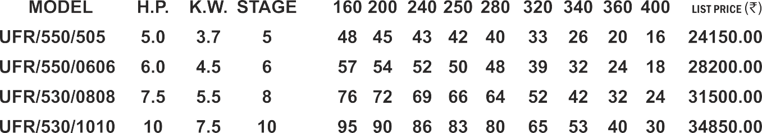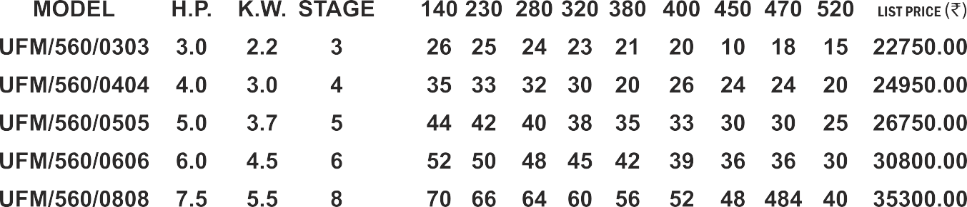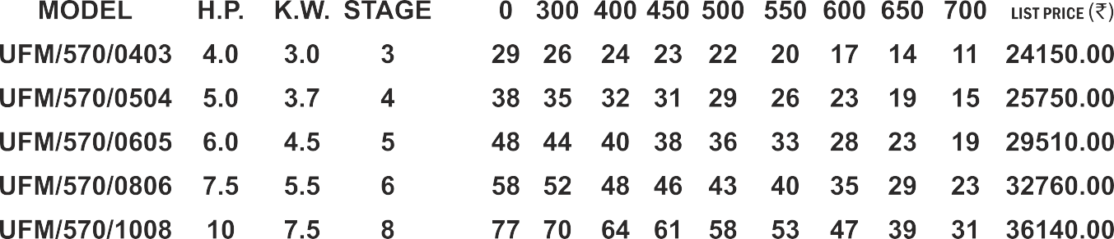

|  |  |  |  |
| --- | --- | --- | --- |
|  |  |  |  |
|  |  |  |  |
|  |  |  |  |
|  |  |  |  |
|  |  |  |  |

|  |  |  |  |  |  |  |  |  |  |
| --- | --- | --- | --- | --- | --- | --- | --- | --- | --- |
|  |  |  |  |  |  |  |  |  |  |
|  |  |  |  |  |  |  |  |  |  |
|  |  |  |  |  |  |  |  |  |  |
|  |  |  |  |  |  |  |  |  |  |
|  |  |  |  |  |  |  |  |  |  |

|  |  |  |  |
| --- | --- | --- | --- |
|  |  |  |  |
|  |  |  |  |
|  |  |  |  |
|  |  |  |  |
|  |  |  |  |
|  |  |  |  |
|  |  |  |  |

|  |  |  |  |  |  |  |  |  |  |
| --- | --- | --- | --- | --- | --- | --- | --- | --- | --- |
|  |  |  |  |  |  |  |  |  |  |
|  |  |  |  |  |  |  |  |  |  |
|  |  |  |  |  |  |  |  |  |  |
|  |  |  |  |  |  |  |  |  |  |
|  |  |  |  |  |  |  |  |  |  |
|  |  |  |  |  |  |  |  |  |  |
|  |  |  |  |  |  |  |  |  |  |

|  |  |  |  |
| --- | --- | --- | --- |
|  |  |  |  |
|  |  |  |  |
|  |  |  |  |
|  |  |  |  |
|  |  |  |  |
|  |  |  |  |

|  |  |  |  |  |  |  |  |  |  |
| --- | --- | --- | --- | --- | --- | --- | --- | --- | --- |
|  |  |  |  |  |  |  |  |  |  |
|  |  |  |  |  |  |  |  |  |  |
|  |  |  |  |  |  |  |  |  |  |
|  |  |  |  |  |  |  |  |  |  |
|  |  |  |  |  |  |  |  |  |  |
|  |  |  |  |  |  |  |  |  |  |

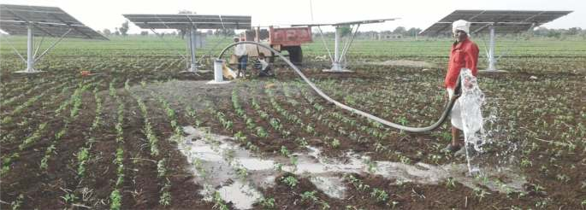

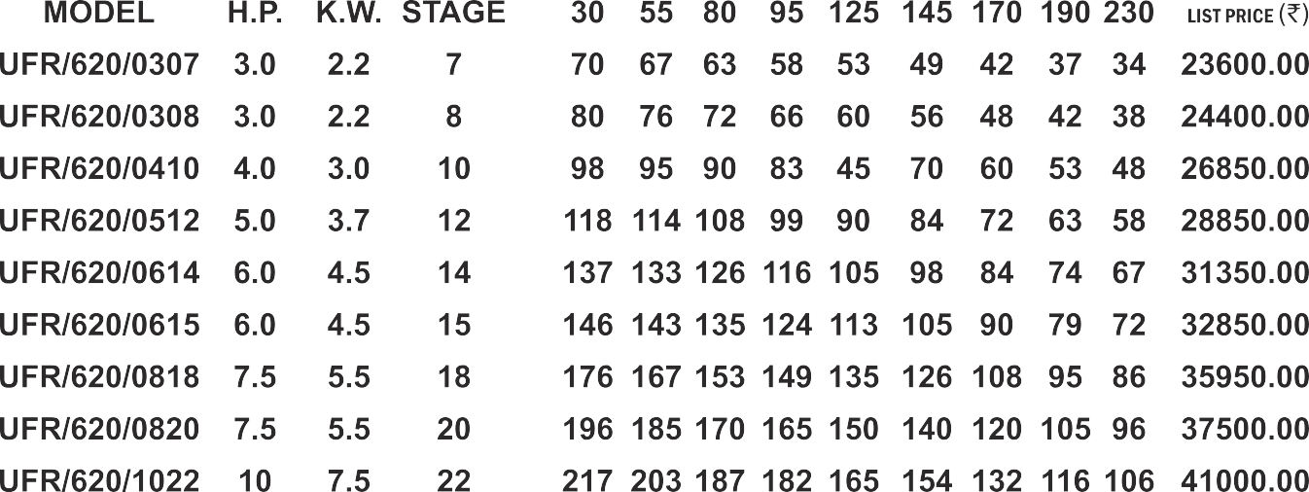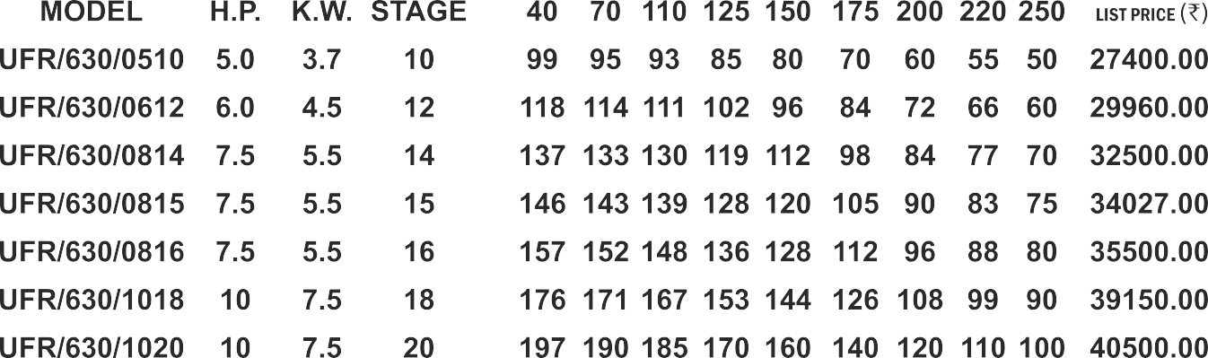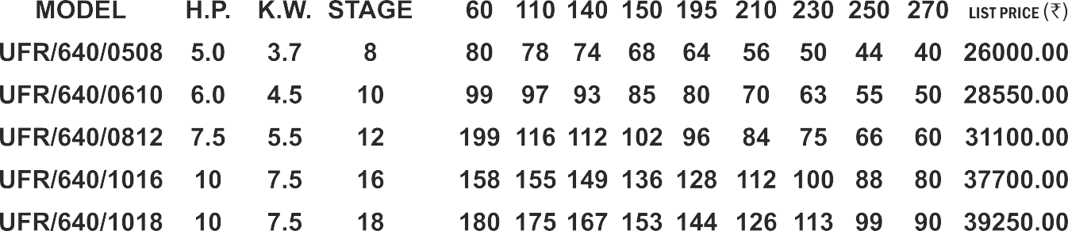

|  |  |  |  |
| --- | --- | --- | --- |
|  |  |  |  |
|  |  |  |  |
|  |  |  |  |
|  |  |  |  |
|  |  |  |  |
|  |  |  |  |
|  |  |  |  |
|  |  |  |  |
|  |  |  |  |
|  |  |  |  |
|  |  |  |  |

|  |  |  |  |  |  |  |  |  |  |
| --- | --- | --- | --- | --- | --- | --- | --- | --- | --- |
|  |  |  |  |  |  |  |  |  |  |
|  |  |  |  |  |  |  |  |  |  |
|  |  |  |  |  |  |  |  |  |  |
|  |  |  |  |  |  |  |  |  |  |
|  |  |  |  |  |  |  |  |  |  |
|  |  |  |  |  |  |  |  |  |  |
|  |  |  |  |  |  |  |  |  |  |
|  |  |  |  |  |  |  |  |  |  |
|  |  |  |  |  |  |  |  |  |  |
|  |  |  |  |  |  |  |  |  |  |
|  |  |  |  |  |  |  |  |  |  |

|  |  |  |  |
| --- | --- | --- | --- |
|  |  |  |  |
|  |  |  |  |
|  |  |  |  |
|  |  |  |  |
|  |  |  |  |
|  |  |  |  |
|  |  |  |  |
|  |  |  |  |

|  |  |  |  |  |  |  |  |  |  |
| --- | --- | --- | --- | --- | --- | --- | --- | --- | --- |
|  |  |  |  |  |  |  |  |  |  |
|  |  |  |  |  |  |  |  |  |  |
|  |  |  |  |  |  |  |  |  |  |
|  |  |  |  |  |  |  |  |  |  |
|  |  |  |  |  |  |  |  |  |  |
|  |  |  |  |  |  |  |  |  |  |
|  |  |  |  |  |  |  |  |  |  |
|  |  |  |  |  |  |  |  |  |  |

|  |  |  |  |
| --- | --- | --- | --- |
|  |  |  |  |
|  |  |  |  |
|  |  |  |  |
|  |  |  |  |
|  |  |  |  |
|  |  |  |  |

|  |  |  |  |  |  |  |  |  |  |
| --- | --- | --- | --- | --- | --- | --- | --- | --- | --- |
|  |  |  |  |  |  |  |  |  |  |
|  |  |  |  |  |  |  |  |  |  |
|  |  |  |  |  |  |  |  |  |  |
|  |  |  |  |  |  |  |  |  |  |
|  |  |  |  |  |  |  |  |  |  |
|  |  |  |  |  |  |  |  |  |  |

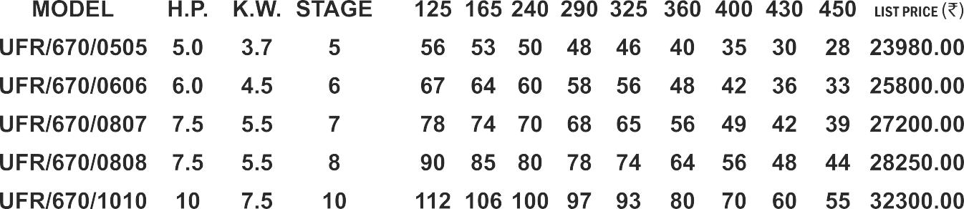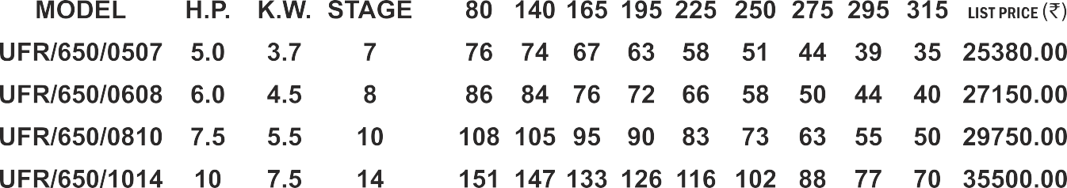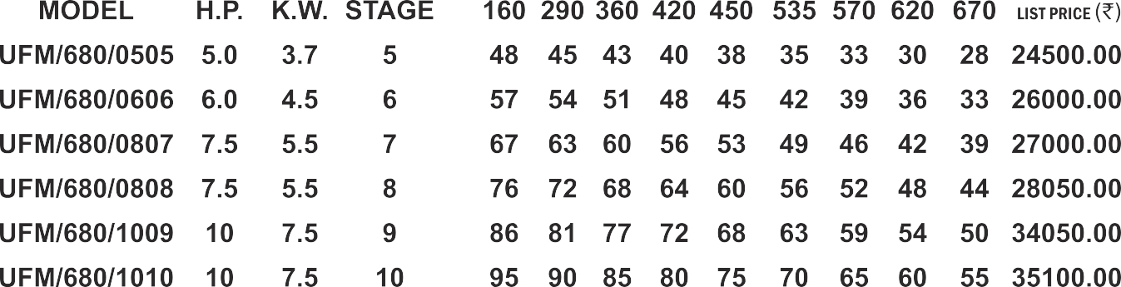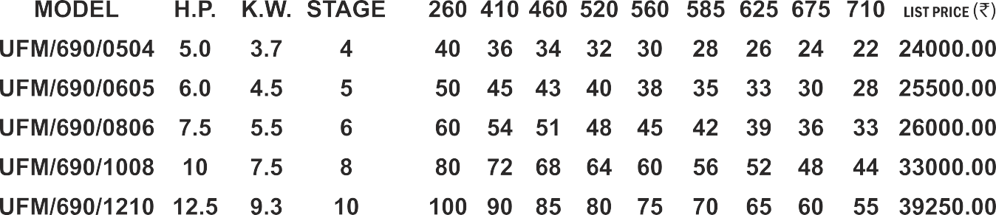

|  |  |  |  |
| --- | --- | --- | --- |
|  |  |  |  |
|  |  |  |  |
|  |  |  |  |
|  |  |  |  |
|  |  |  |  |

|  |  |  |  |  |  |  |  |  |  |
| --- | --- | --- | --- | --- | --- | --- | --- | --- | --- |
|  |  |  |  |  |  |  |  |  |  |
|  |  |  |  |  |  |  |  |  |  |
|  |  |  |  |  |  |  |  |  |  |
|  |  |  |  |  |  |  |  |  |  |
|  |  |  |  |  |  |  |  |  |  |

|  |  |  |  |
| --- | --- | --- | --- |
|  |  |  |  |
|  |  |  |  |
|  |  |  |  |
|  |  |  |  |
|  |  |  |  |
|  |  |  |  |

|  |  |  |  |  |  |  |  |  |  |
| --- | --- | --- | --- | --- | --- | --- | --- | --- | --- |
|  |  |  |  |  |  |  |  |  |  |
|  |  |  |  |  |  |  |  |  |  |
|  |  |  |  |  |  |  |  |  |  |
|  |  |  |  |  |  |  |  |  |  |
|  |  |  |  |  |  |  |  |  |  |
|  |  |  |  |  |  |  |  |  |  |

|  |  |  |  |
| --- | --- | --- | --- |
|  |  |  |  |
|  |  |  |  |
|  |  |  |  |
|  |  |  |  |
|  |  |  |  |
|  |  |  |  |
|  |  |  |  |

|  |  |  |  |  |  |  |  |  |  |
| --- | --- | --- | --- | --- | --- | --- | --- | --- | --- |
|  |  |  |  |  |  |  |  |  |  |
|  |  |  |  |  |  |  |  |  |  |
|  |  |  |  |  |  |  |  |  |  |
|  |  |  |  |  |  |  |  |  |  |
|  |  |  |  |  |  |  |  |  |  |
|  |  |  |  |  |  |  |  |  |  |
|  |  |  |  |  |  |  |  |  |  |

|  |  |  |  |  |  |  |  |  |  |
| --- | --- | --- | --- | --- | --- | --- | --- | --- | --- |
|  |  |  |  |  |  |  |  |  |  |
|  |  |  |  |  |  |  |  |  |  |
|  |  |  |  |  |  |  |  |  |  |
|  |  |  |  |  |  |  |  |  |  |
|  |  |  |  |  |  |  |  |  |  |
|  |  |  |  |  |  |  |  |  |  |

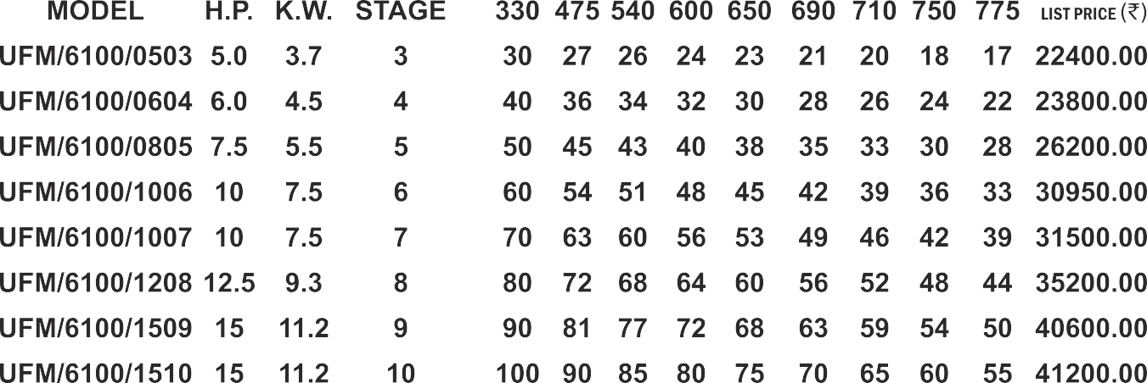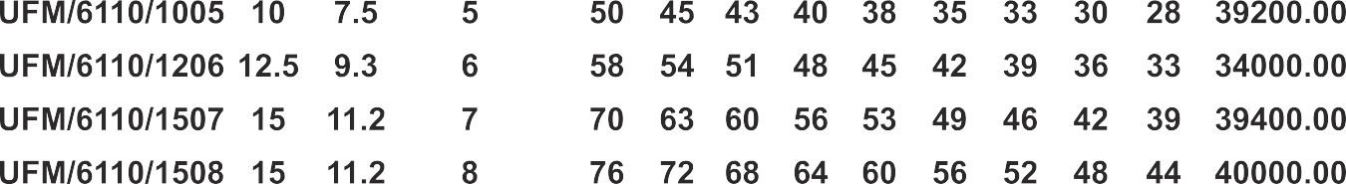

|  |  |  |  |
| --- | --- | --- | --- |
|  |  |  |  |
|  |  |  |  |
|  |  |  |  |
|  |  |  |  |
|  |  |  |  |
|  |  |  |  |
|  |  |  |  |
|  |  |  |  |
|  |  |  |  |

|  |  |  |  |  |  |  |  |  |  |
| --- | --- | --- | --- | --- | --- | --- | --- | --- | --- |
|  |  |  |  |  |  |  |  |  |  |
|  |  |  |  |  |  |  |  |  |  |
|  |  |  |  |  |  |  |  |  |  |
|  |  |  |  |  |  |  |  |  |  |
|  |  |  |  |  |  |  |  |  |  |
|  |  |  |  |  |  |  |  |  |  |
|  |  |  |  |  |  |  |  |  |  |
|  |  |  |  |  |  |  |  |  |  |
|  |  |  |  |  |  |  |  |  |  |

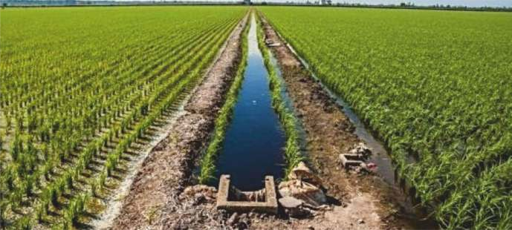

|  |  |  |  |
| --- | --- | --- | --- |
|  |  |  |  |
|  |  |  |  |
|  |  |  |  |
|  |  |  |  |
|  |  |  |  |
|  |  |  |  |
|  |  |  |  |

|  |  |  |  |  |  |  |  |  |  |
| --- | --- | --- | --- | --- | --- | --- | --- | --- | --- |
|  |  |  |  |  |  |  |  |  |  |
|  |  |  |  |  |  |  |  |  |  |
|  |  |  |  |  |  |  |  |  |  |
|  |  |  |  |  |  |  |  |  |  |
|  |  |  |  |  |  |  |  |  |  |
|  |  |  |  |  |  |  |  |  |  |
|  |  |  |  |  |  |  |  |  |  |

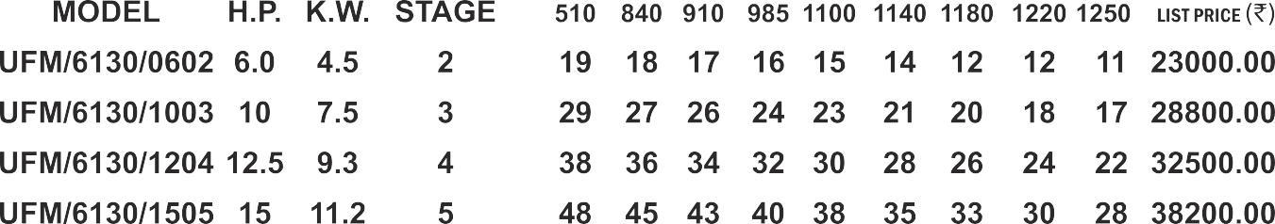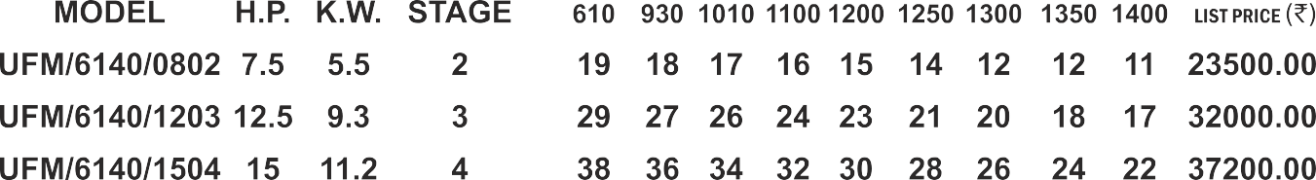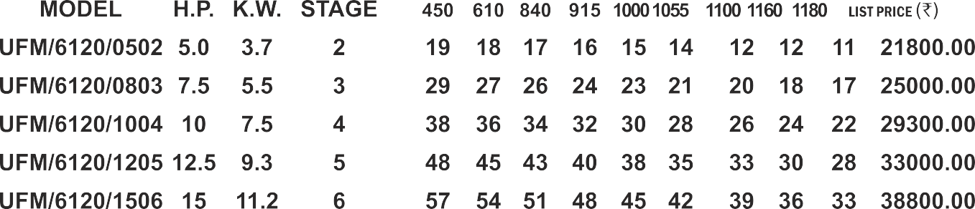

|  |  |  |  |
| --- | --- | --- | --- |
|  |  |  |  |
|  |  |  |  |
|  |  |  |  |
|  |  |  |  |
|  |  |  |  |
|  |  |  |  |

|  |  |  |  |  |  |  |  |  |  |
| --- | --- | --- | --- | --- | --- | --- | --- | --- | --- |
|  |  |  |  |  |  |  |  |  |  |
|  |  |  |  |  |  |  |  |  |  |
|  |  |  |  |  |  |  |  |  |  |
|  |  |  |  |  |  |  |  |  |  |
|  |  |  |  |  |  |  |  |  |  |
|  |  |  |  |  |  |  |  |  |  |



|  |  |  |  |
| --- | --- | --- | --- |
|  |  |  |  |
|  |  |  |  |
|  |  |  |  |
|  |  |  |  |
|  |  |  |  |

|  |  |  |  |  |  |  |  |  |  |
| --- | --- | --- | --- | --- | --- | --- | --- | --- | --- |
|  |  |  |  |  |  |  |  |  |  |
|  |  |  |  |  |  |  |  |  |  |
|  |  |  |  |  |  |  |  |  |  |
|  |  |  |  |  |  |  |  |  |  |
|  |  |  |  |  |  |  |  |  |  |

|  |  |  |  |
| --- | --- | --- | --- |
|  |  |  |  |
|  |  |  |  |
|  |  |  |  |
|  |  |  |  |

|  |  |  |  |  |  |  |  |  |  |
| --- | --- | --- | --- | --- | --- | --- | --- | --- | --- |
|  |  |  |  |  |  |  |  |  |  |
|  |  |  |  |  |  |  |  |  |  |
|  |  |  |  |  |  |  |  |  |  |
|  |  |  |  |  |  |  |  |  |  |

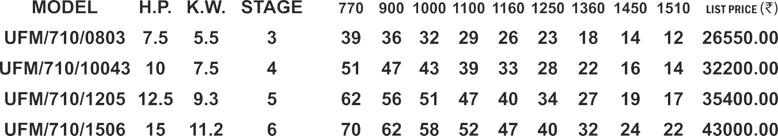

|  |  |  |  |
| --- | --- | --- | --- |
|  |  |  |  |
|  |  |  |  |
|  |  |  |  |
|  |  |  |  |
|  |  |  |  |

|  |  |  |  |  |  |  |  |  |  |
| --- | --- | --- | --- | --- | --- | --- | --- | --- | --- |
|  |  |  |  |  |  |  |  |  |  |
|  |  |  |  |  |  |  |  |  |  |
|  |  |  |  |  |  |  |  |  |  |
|  |  |  |  |  |  |  |  |  |  |
|  |  |  |  |  |  |  |  |  |  |

|  |  |  |  |
| --- | --- | --- | --- |
|  |  |  |  |
|  |  |  |  |
|  |  |  |  |
|  |  |  |  |
|  |  |  |  |

|  |  |  |  |  |  |  |  |  |  |
| --- | --- | --- | --- | --- | --- | --- | --- | --- | --- |
|  |  |  |  |  |  |  |  |  |  |
|  |  |  |  |  |  |  |  |  |  |
|  |  |  |  |  |  |  |  |  |  |
|  |  |  |  |  |  |  |  |  |  |
|  |  |  |  |  |  |  |  |  |  |

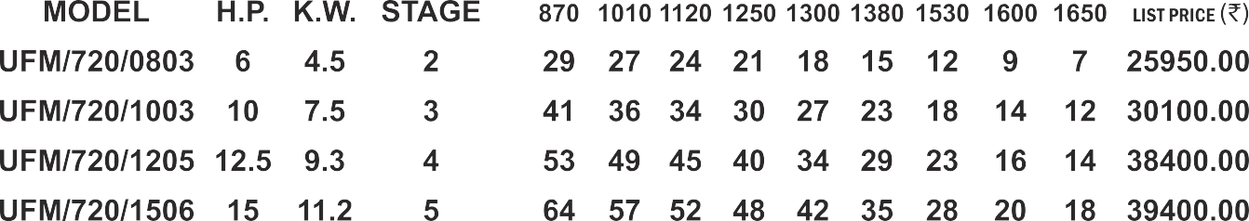OUTLET : 100 MM DISCHARGE IN LPM

|  |  |  |  |
| --- | --- | --- | --- |
| **MODEL** | **H.P.** | **K.W.** | **STAGE** |
| **UFM/730/0802** | **7.5** | **5.5** | **2** |
| **UFM/730/1203** | **12.5** | **9.3** | **3** |
| **UFM/730/1504** | **15** | **11.2** | **4** |

|  |  |  |  |  |  |  |  |  |  |
| --- | --- | --- | --- | --- | --- | --- | --- | --- | --- |
| **960** | **1050** | **1190** | **1310** | **1400** | **1490** | **1640** | **1780** | **1840** | **LIST PRICE** (`) |
| **29** | **27** | **24** | **21** | **18** | **15** | **12** | **9** | **7** | **24500.00** |
| **42** | **38** | **36** | **32** | **28** | **24** | **19** | **15** | **12** | **32600.00** |
| **55** | **49** | **45** | **40** | **36** | **32** | **25** | **18** | **15** | **38800.00** |

|  |  |  |  |
| --- | --- | --- | --- |
|  |  |  |  |
|  |  |  |  |
|  |  |  |  |

|  |  |  |  |  |  |  |  |  |  |
| --- | --- | --- | --- | --- | --- | --- | --- | --- | --- |
|  |  |  |  |  |  |  |  |  |  |
|  |  |  |  |  |  |  |  |  |  |
|  |  |  |  |  |  |  |  |  |  |

|  |  |  |  |
| --- | --- | --- | --- |
|  |  |  |  |
|  |  |  |  |
|  |  |  |  |

|  |  |  |  |  |  |  |  |  |  |
| --- | --- | --- | --- | --- | --- | --- | --- | --- | --- |
|  |  |  |  |  |  |  |  |  |  |
|  |  |  |  |  |  |  |  |  |  |
|  |  |  |  |  |  |  |  |  |  |



        
        
        
        
        
        

                
                
                
                
                
                

        
        
        
        
        

                
                
                
                
                

        
        
        
        
        

                
                
                
                
                

        
        
        
        

                
                
                
                